Phase 1: Ideation Phase

To Supply Leftover Food to Poor:
In this phase, the main idea of the project is developed. The goal is to create a system on Salesforce that connects restaurants, events, and donors with NGOs or needy people to supply leftover food. Brainstorming sessions are held to identify the problem (food wastage) and come up with a digital solution that ensures timely food distribution.
Phase 2: Project Planning phase
In the planning phase, the team defines the project scope, objectives, and timeline. Roles and responsibilities are assigned, and the required Salesforce tools (like Service Cloud, custom apps, or automation) are decided. A roadmap is created for how the system will be developed, tested, and implemented.

Milestone 1: Salesforce developer account creation Activity 1: Creating Developer Account
Creating a developer org in salesforce.
- Go to https://developer.salesforce.com/signup
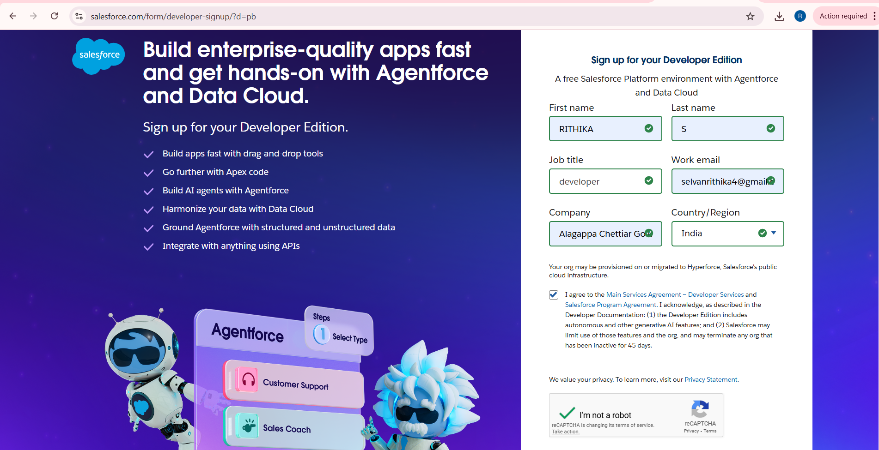

- On the sign up form, enter the following details :
  - First name & Last name
  - Email
  - Role : Developer
  - Company : College or Company Name
  - County : India
6. Postal Code : pin code
7. Username : should be a combination of your name and company This need not be an actual email id, you can give anything in the format : username@organization.com
Click on sign me up after filling these.

Activity 2: Account Activation

- Go to the inbox of the email that you used while signing up. Click on the verify account to activate your account. The email may take 5-10mins.

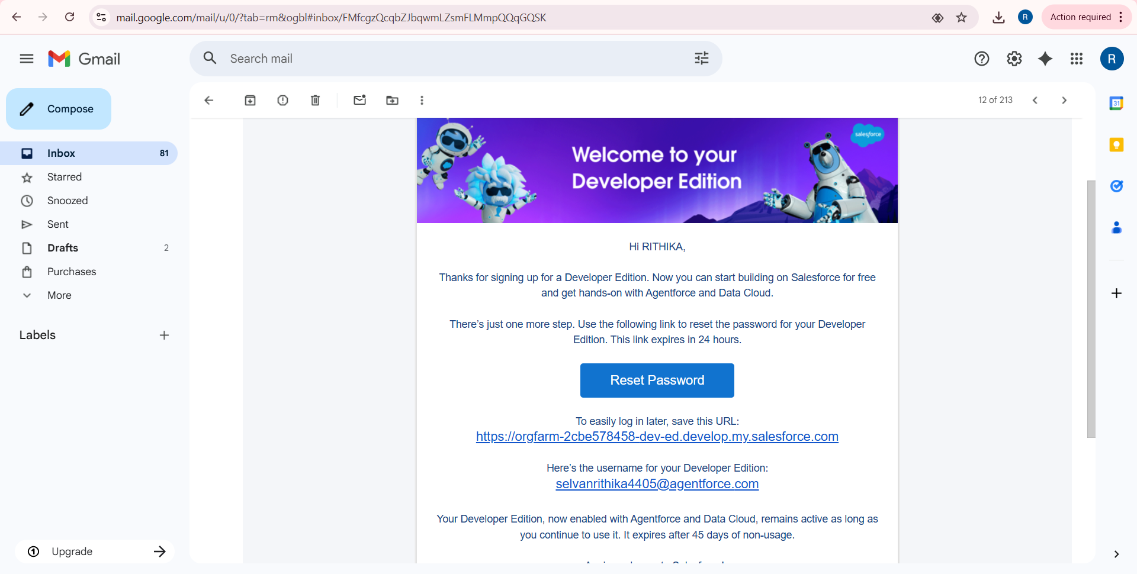

2.Click on Verify Account
  - Give a password and answer a security question and click on change password.
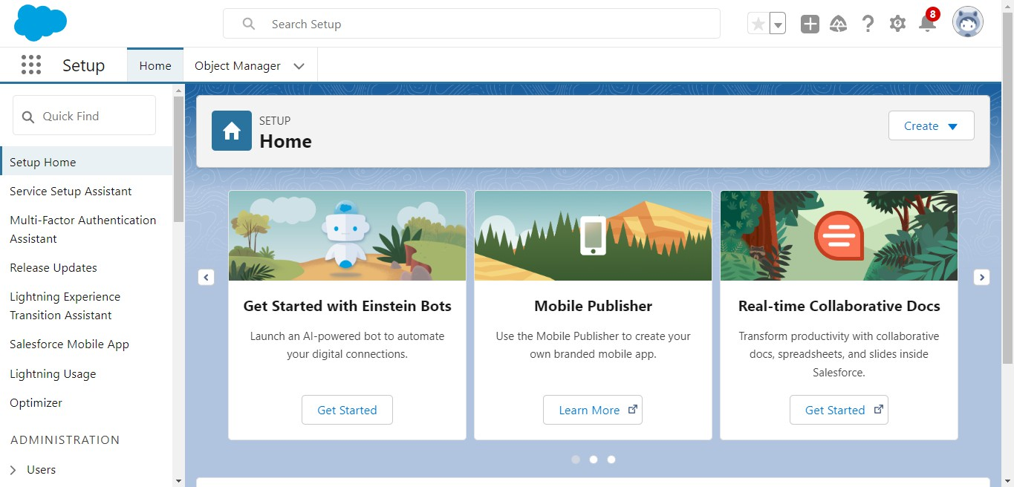
  - Then you will redirect to your salesforce setup page.

Milestone 2 : OBJECT :-
To Navigate to Setup page:

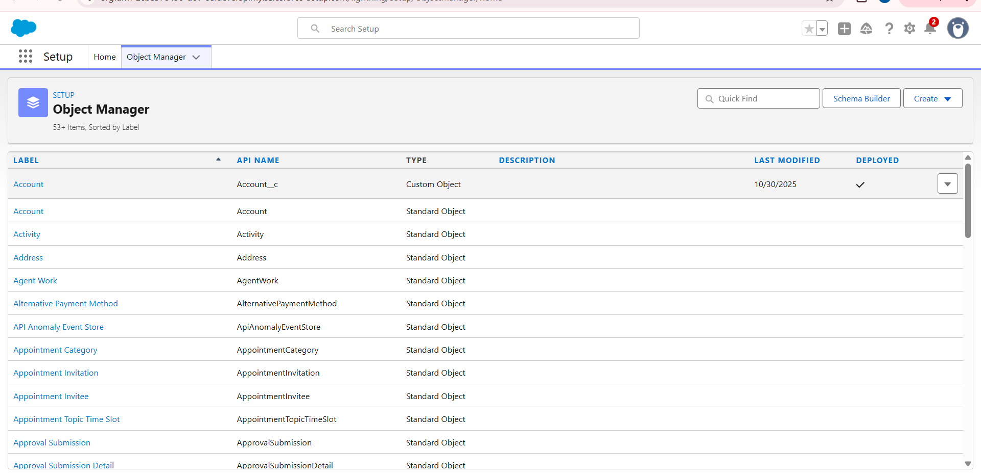

To create an object:
- From the setup page > Click on Object Manager > Click on Create > Click on Custom Object.
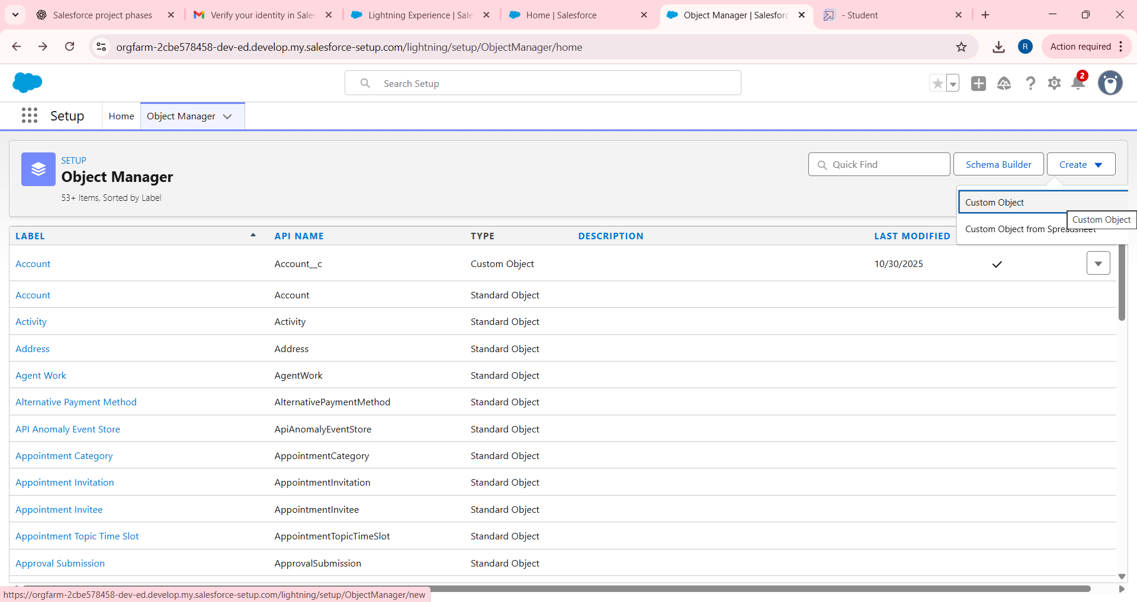
- On Custom object defining page:

- Enter the label name, plural label name, click on Allow reports, Allow search.

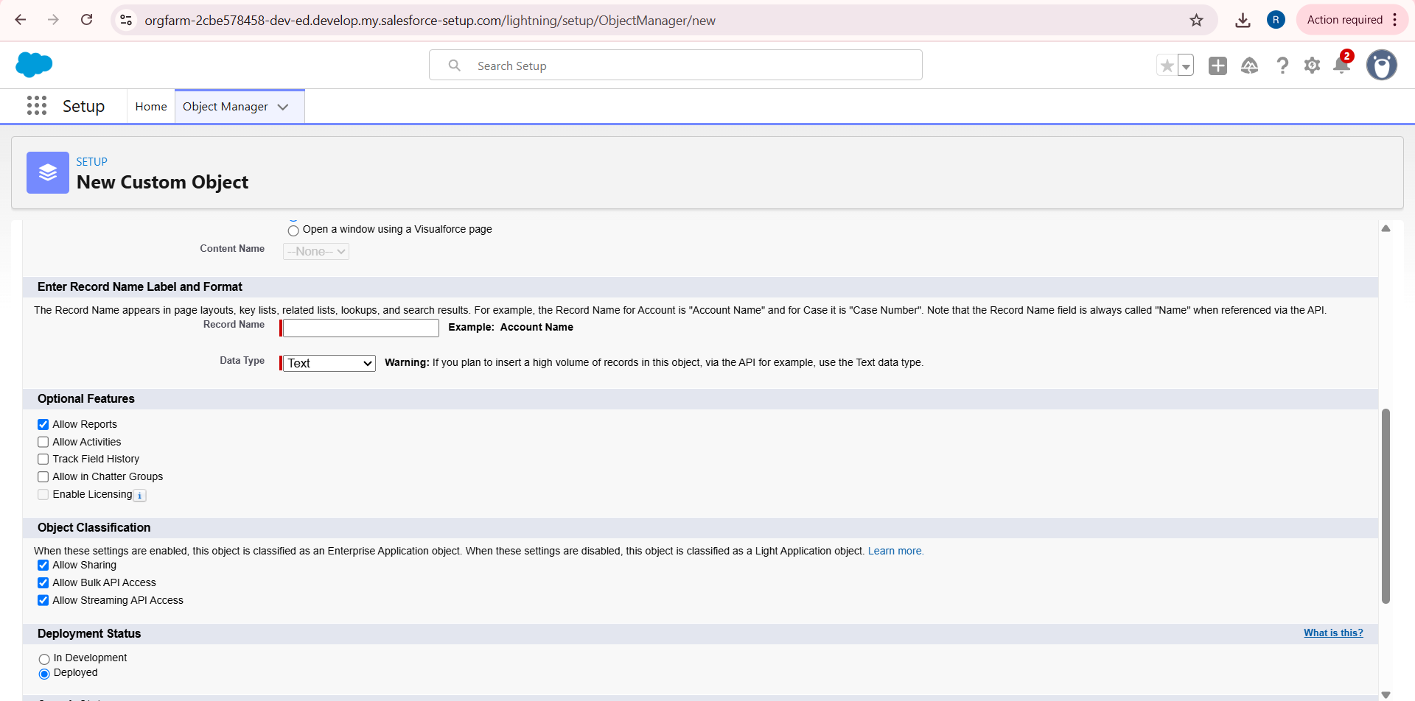

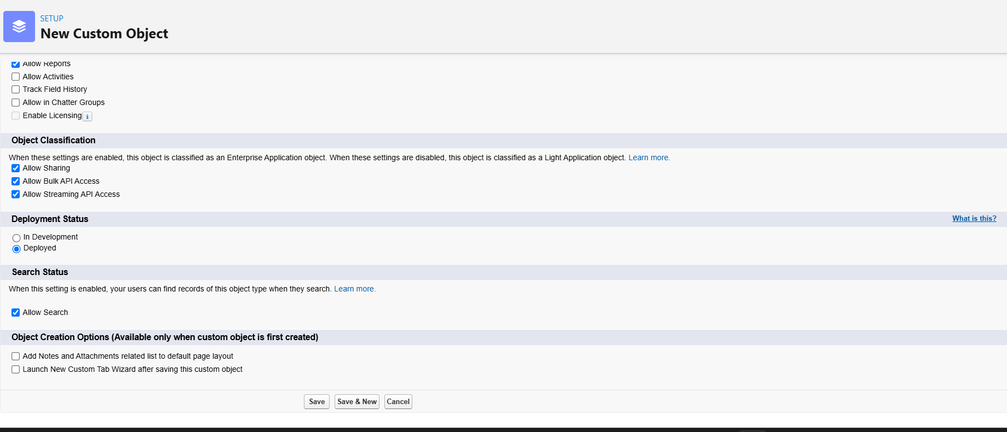

- Click on Save.

Activity 1: Create Venue Object:-

To create an object:
  - From the setup page >> Click on Object Manager >> Click on Create >> Click on Custom Object.
    - Enter the label name >> Venue
    - Plural label name >> Venues
    - Enter Record Name Label and Format
      - Record Name >> Venue Name
      - Data Type >> Text

  - Click on Allow reports and Track Field History,Allow Activities.
  - Allow search >> Save.

Activity 2: Create Drop-Off Point Object:-

To create an object:
- From the setup page >> Click on Object Manager >> Click on Create >> Click on Custom Object.
  - Enter the label name >> Drop-Off Point
  - Plural label name>> Drop-Off Points
  - Enter Record Name Label and Format
    - Record Name >> Drop-Off point Name
    - Data Type >> Text

- Click on Allow reports and Track Field History,Allow Activities
- Allow search >> Save.

Activity 3: Create Task Object:-

To create an object:
- From the setup page >> Click on Object Manager >> Click on Create >> Click on Custom Object.
  - Enter the label name>> Task
  - Plural label name>> Tasks
  - Enter Record Name Label and Format
    - Record Name >> Task Name
    - Data Type >> Text

- Click on Allow reports and Track Field History,Allow Activities
- Allow search >> Save.

Activity 4: Create Volunteer Object:-

To create an object:
- From the setup page >> Click on Object Manager>> Click on Create >> Click on Custom Object.
  - Enter the label name>> Volunteer
  - Plural label name>> Volunteers
  - Enter Record Name Label and Format
    - Record Name >> Volunteer Name
    - Data Type >> Text

- Click on Allow reports and Track Field History, Allow Activities
- Allow search >> Save.

Activity 5: Create Execution Details Object:-

To create an object:
- From the setup page >> Click on Object Manager >> Click on Create >> Click on Custom Object.
  - Enter the label name >> Execution Detail
  - Plural label name >> Execution Details
  - Enter Record Name Label and Format
    - Record Name >> Execution Detail Name
    - Data Type >> Text
- Click on Allow reports and Track Field History, Allow Activities.

- Allow search >> Save

Milestone 3 : TABS :-

What is Tab : A tab is like a user interface that is used to build records for objects and to view the records in the objects.

Activity 1: Creating a Custom Tab:-

To create a Tab:(Venue)
- Go to setup page >> type Tabs in Quick Find bar >> click on tabs >> New (under custom object tab)
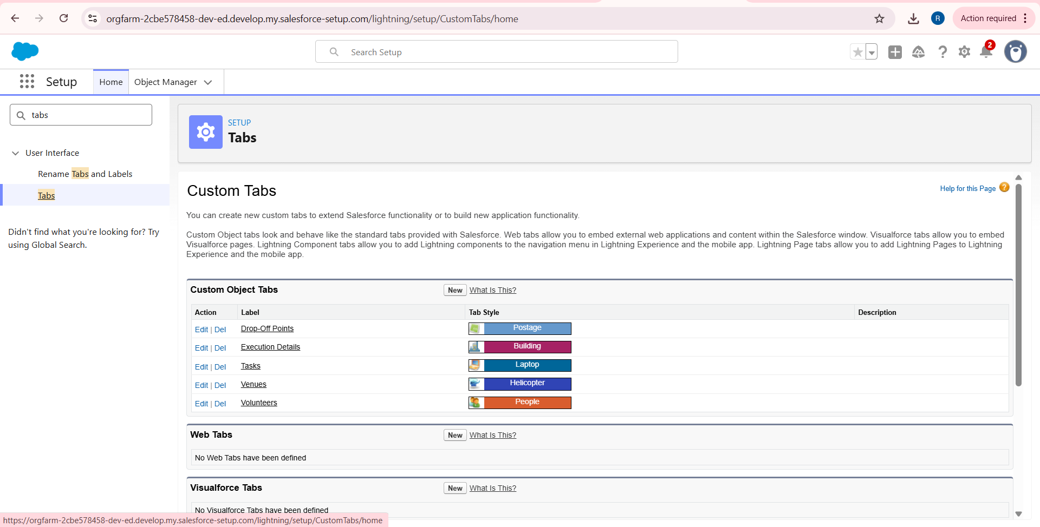

- Select Object(Venue) >> Select the tab style >> Next (Add to profiles page) keep it as default >> Next (Add to Custom App) uncheck the include tab .
- Make sure that the Append tab to users' existing personal customizations is checked.
- Click save.

Activity 2: Creating Remaining Tabs:-

  - Now create the Tabs for the remaining Objects, they are “Drop-Off Point, Task, Volunteer, Execution Details”.
  - Follow the same steps as mentioned in Activity -1.

